Activity Sheet Name ______________________
Chapter 6, Lesson 11
Chemical Reactions & Engineering Design Date

DEFINE THE PROBLEM
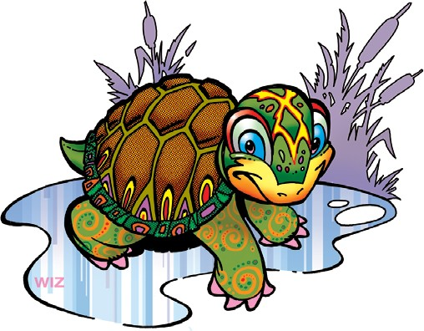
Imagine that you volunteered to rescue reptiles (turtles, snakes, and lizards) that are in the unlucky position of living in the path of new construction. Typically, in these cases, animals move. They search for new homes and food sources nearby. However, eggs cannot crawl, slither, or swim to another location. And construction projects will not wait for eggs to hatch.
You have talked with the construction workers and with a nearby reptile conservation center. The workers are willing to notify you when they come across reptile eggs. The center can incubate the eggs until the babies hatch and then return them to the wild. Your role is to design a reptile egg incubation device that keeps an egg warm and safe as it is transported from the worksite to the reptile conservation center.

Reptile eggs are leathery and soft. While they are not prone to crack easily, they need to remain in the same orientation they were originally laid— whatever is facing up, must stay facing up. They cannot be flipped, turned, or jostled. Very importantly, the eggs must be kept warm, but not too warm, to properly develop and hatch.
You have a job to do before the first batch of eggs is found—build a temporary portable reptile egg incubator device that will keep one egg warm and properly positioned while you take it to the reptile conservation center.

Let’s give these young lizards, turtles, and snakes their best chance at life!

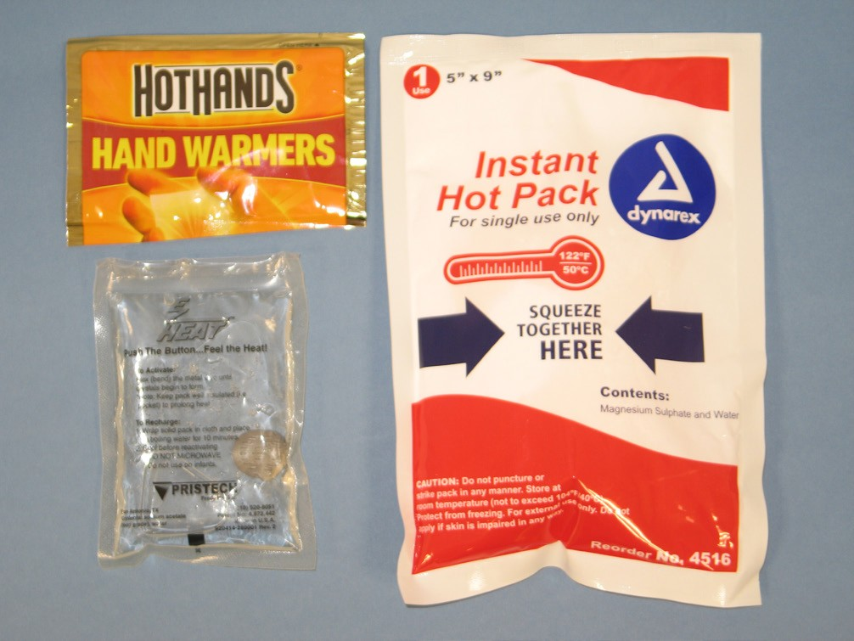
Inspiration for an invention can come from just about anywhere. Sometimes it can come from products that already exist.
- What features of the three hot packs shown in the video keep them from getting hot before you want them to?

- The features that a device must have to make it work are called the criteria.
As you begin to think about a temporary portable reptile egg incubator, what features might be useful to borrow from the design of the hot packs?

- Possible problems that might prevent the design from successfully meeting all the criteria are called constraints.
What are possible constraints, or challenges, which would prevent you from getting the features you listed above?

DEVELOP POSSIBLE SOLUTIONS
Think back to the story about transporting reptile eggs from a construction site to a reptile conservation center. Read the text message from one of the construction workers in the illustration to the right.

- Look at the Reptile Egg Identification chart on the next page to answer the following questions:

- Do these eggs belong to a snake, turtle, or lizard?

- What characteristics helped you identify these eggs?

- As you design your temporary portable reptile egg incubator, you will need to consider the ideal temperature the reptile eggs need. What temperature range should you aim for when you mix calcium chloride, baking soda, and water?

Reptile Egg Identification Chart
Reptile eggs have a leathery shell and are found on or just under the ground. Care must be used when handling them, because they can be quite fragile. Also, the eggs should never be turned over: Whichever part is facing up must always face up until the reptile has hatched. Turning the eggs over could harm the developing embryo!

Snake
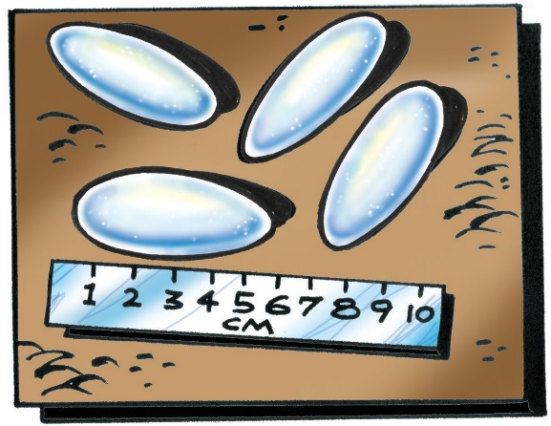 | Location  Snake eggs are found in a hidden location on top of soil, dried leaves, or mulch. | Length  4-10 cm
 | Shape  Snake eggs are oblong and irregularly shaped. | Incubation temperature 28-32°C
Turtle
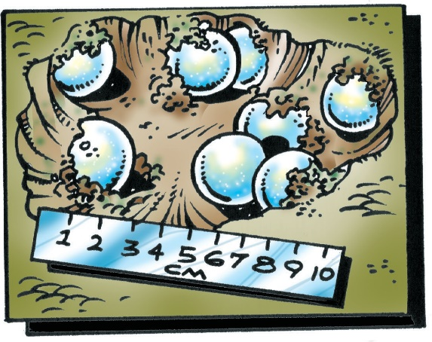 | Location  Turtle eggs are buried in loose soil. A spoon and  paint brush can be used  to carefully remove these. | Length  2-5 cm
 | Shape  Turtle eggs are about the size and shape of ping pong balls. | Incubation temperature 24-28°C
Lizard
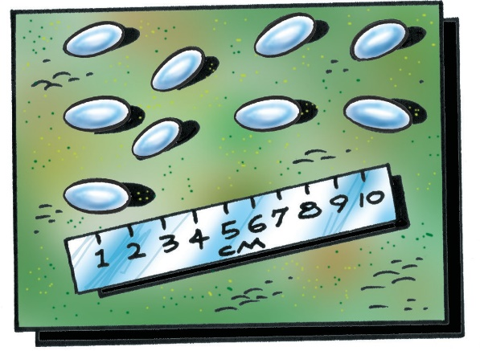 | Location  Lizard eggs are laid on soil, mulch, or dried leaves. | Length  1-3 cm
 | Shape  Lizard eggs are oblong and irregularly shaped. | Incubation temperature 26-30°C

Question to investigate
Does the amount of calcium chloride dissolved in water affect the temperature change?

You will need
- Goggles
- 2 small thermometers
- Calcium chloride
- Baking soda
- Water
- 2 small clear plastic cups
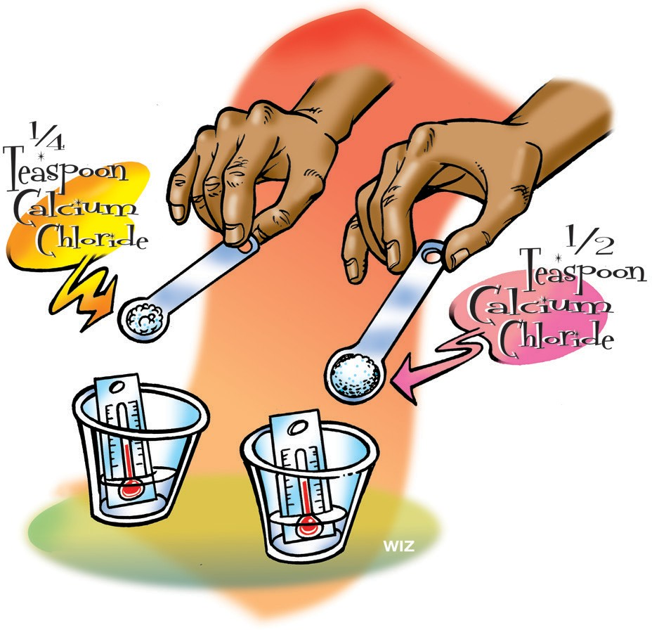
- 1 graduated cylinder
- Measuring spoons (⅛ tsp., ¼ tsp., and ½ tsp.)

Procedure
- Pour 15 mL of water into each of two small clear plastic cups.
- Place a small thermometer in each cup and record the initial temperature in the chart below.
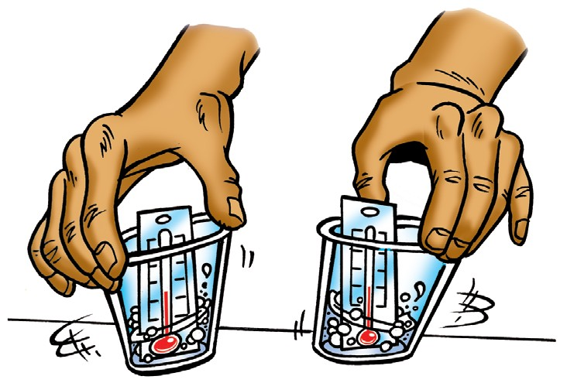
- With the help of a partner and at the same time, add ¼ tsp. calcium chloride to one cup and ½ tsp. of calcium chloride to the other cup.

- With the thermometers still in the cups, gently swirl both cups and check the temperature of both. Record the highest final temperature each reaches.

How much does the temperature increase?
 | ¼ tsp. calcium chloride | ½ tsp. calcium chloride
Initial temperature  Just water | °C | °C
Final temperature  Water plus calcium chloride | °C | °C
Change in temperature  Final temp.– Initial temp. | °C | °C

Procedure, continued
5. Add about ⅛ teaspoon of baking soda to the solution that reached the highest temperature. Watch the solution and the thermometer.
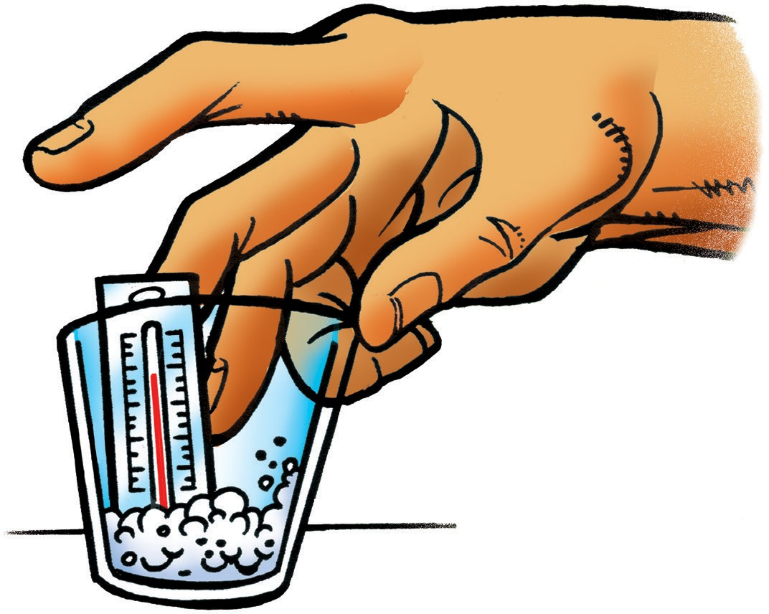
6. With the thermometer still in the cup, gently swirl and check the temperature. Record the lowest final temperature reached.
How does baking soda affect the temperature
of the calcium chloride solution?
Temperature of the calcium chloride solution from Step 4 | °C
Calcium chloride solution plus ⅛ teaspoon baking soda | °C
Change in temperature | °C

Should we use baking soda in the design of
a portable reptile egg incubator?
Disadvantages | Advantages

Question to investigate
About how much calcium chloride, baking soda, and water should be mixed to reach the right temperature range to incubate snake eggs?

You will need
- Calcium chloride
- Baking soda
- Measuring spoons (⅛ tsp., ¼ tsp., and ½ tsp.)
- 2 small clear plastic cups
- Water
- Thermometer
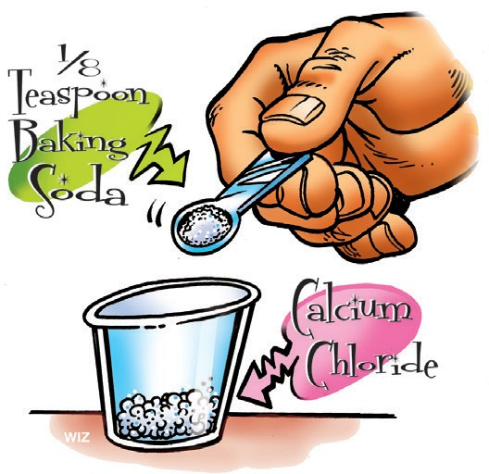

Procedure
- Place ½ tsp. of calcium chloride in a cup.
- To the same cup, add ⅛ tsp. of baking soda.
- Swirl the cup to mix these dry ingredients.
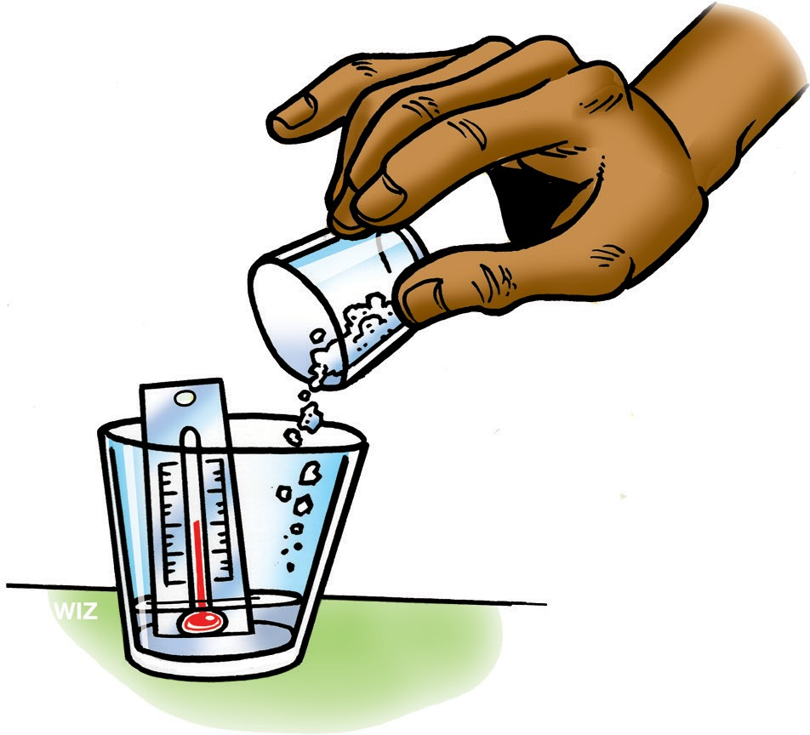
- In a separate cup, add 15 milliliters of water, place a thermometer in the cup, and record the temperature.
- With the thermometer in the cup, add all of the mixture of calcium chloride and baking soda and gently swirl to mix.
- Record the final temperature.
- Adjust the amount of calcium chloride or baking soda and try the reaction two more times to achieve the target temperature.
About how much calcium chloride, baking soda, and water should be mixed
to reach the right temperature range to incubate snake eggs?
Calcium chloride | ½ tsp.
Baking soda | ⅛ tsp.
Water | 15 mL | 15 mL | 15 mL
Initial temperature Just water | °C | °C | °C
Final temperature Highest temperature | °C | °C | °C

DEVELOP POSSIBLE SOLUTIONS
Would the chemical reaction you tested in this lesson work if it were sealed in a plastic bag? Sealing the chemicals in a plastic bag would mean that you would be able to bring just the portable reptile egg incubator with you rather than carry all the supplies needed for each of your tests. In this lesson, you will combine calcium chloride and baking soda in a zip-closing plastic bag to see if this design will keep reptile eggs warm enough.

Question to investigate
Does enough heat transfer through the plastic bag to reach the right temperature range?

You will need
- Calcium chloride
- Baking soda
- Measuring spoons (⅛ tsp., ¼ tsp., and ½ tsp.)
- Graduated cylinder
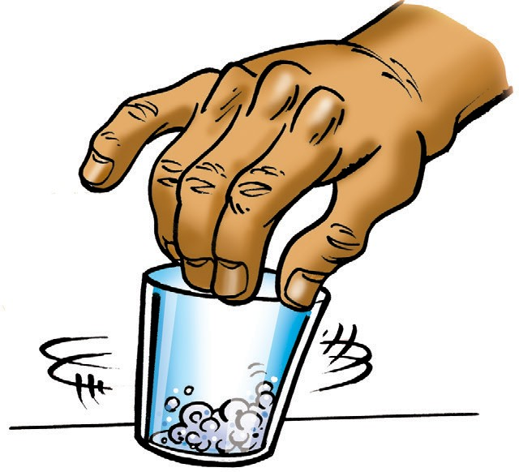
- 2 small clear plastic cups
- Small zip-closing plastic bag
- Water
- Thermometer

Procedure
Combine chemicals in a cup
- Place the amount of calcium chloride and baking soda, which resulted in the best temperature in the previous procedure, in a cup.
- Swirl the cup to mix these dry ingredients as well as you can.
Prepare the bag
- Pour the combined powders into one corner of a small zip-closing plastic bag. Tilt the bag so that all the calcium chloride and baking soda stays in one corner.

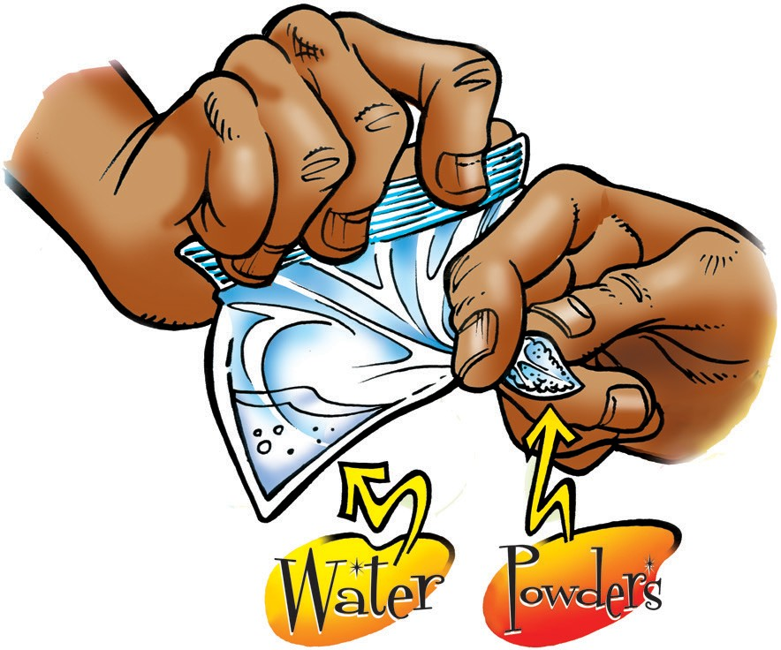
- Use your fingers to seal off that part of the bag.
- Have your partner pour 15 milliliters water into the other corner of the bag so that the water does not touch the dry powders.
- While keeping the water and powders separated, try to get the air out of the bag as you close it and make sure that it is tightly sealed.
Start the chemical reaction
7. Let go of the corner and tilt the bag so that the water and the powders mix and react.
8. Position a thermometer under the bag so that the bulb is beneath the solution where the chemical reaction is taking place.
Be sure you can read the temperature without having to remove the thermometer. Record the highest temperature reached.

What temperature does the thermometer reach when it is placed
beneath the solution where the chemical reaction is taking place?
Highest temperature reached | °C

5. Since the plastic bag will be part of the portable egg incubator, enough heat needs to transfer through the bag to the egg. Does enough heat transfer through the bag to warm a snake egg enough?

6. The bag inflates slightly. How could this feature be useful in the design of the portable snake egg incubator?

OPTIMIZE THE DESIGN
7. Draw your design for a temporary portable snake egg incubator in the large space below. In your drawing use captions to point out how your device meets the following requirements:

  - Keep the egg at the ideal temperature for as long as possible
  - Hold the egg in the proper orientation
  - Protect the egg from impact

Reptiles rescued!
Congratulations, your device works! It was used to take the snake eggs from the construction site safely to the reptile conservation center. The eggs were carefully placed in incubators and both the temperature and humidity were ideal for the growth of healthy snakes.

Because most reptiles can feed and take care of themselves as soon as they hatch, the baby snakes will be taken to a new location and released into the wild. There they will make their new home as they strive to survive and thrive.

